ASSIGNMENT 7.3

1. Top 5 employees (employee id and employee name) with highest rating.

re1 = load ‘/user/acadgild/employee’ using PigStorage(‘,’) as (id:int, name:chararray, sal:int,rating:int);

LOAD: Load the employee data set into pig with the relation re1.

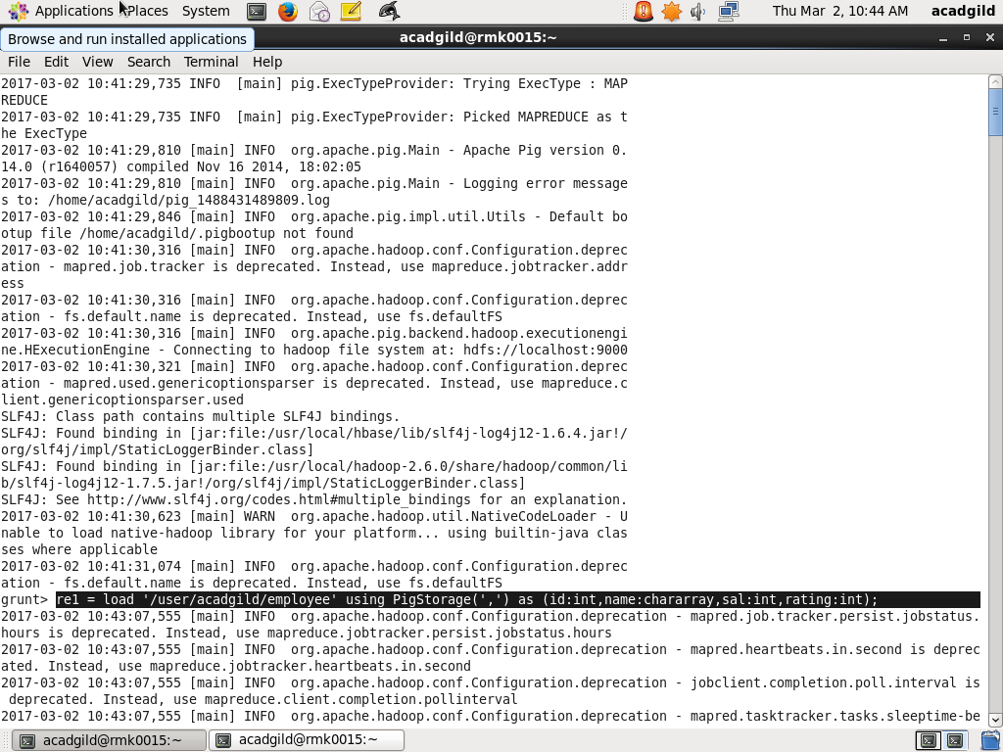

Output of the employee data set.

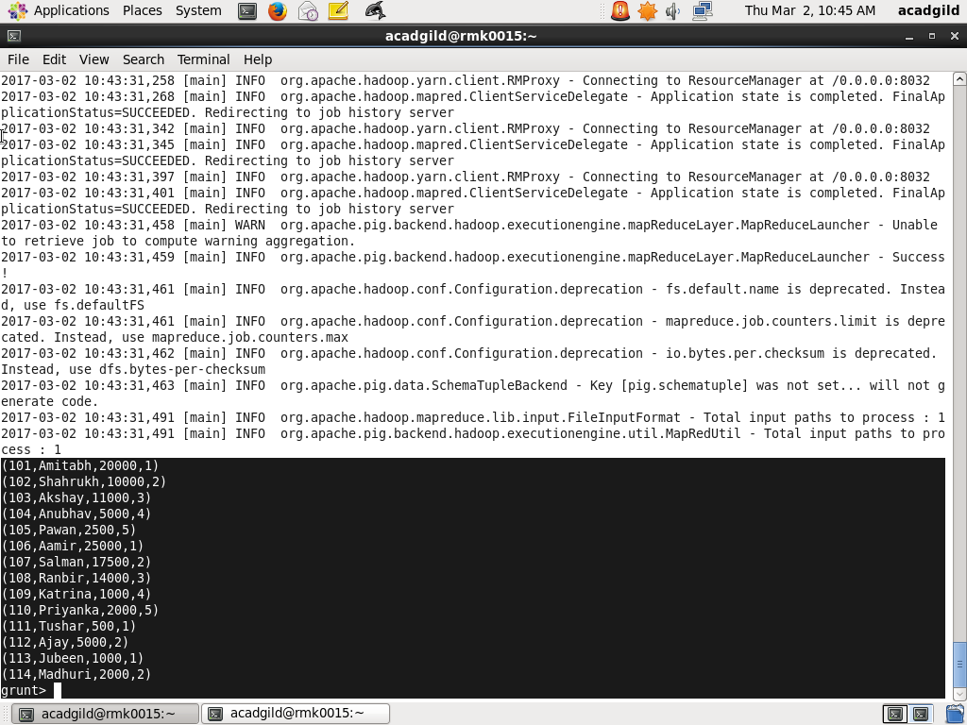

ORDER: Order the relation re1 by rating in descending order and name.

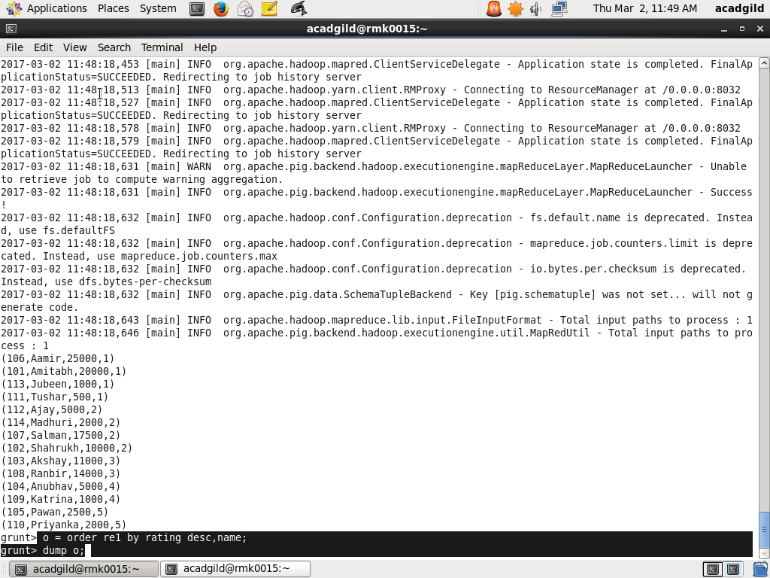

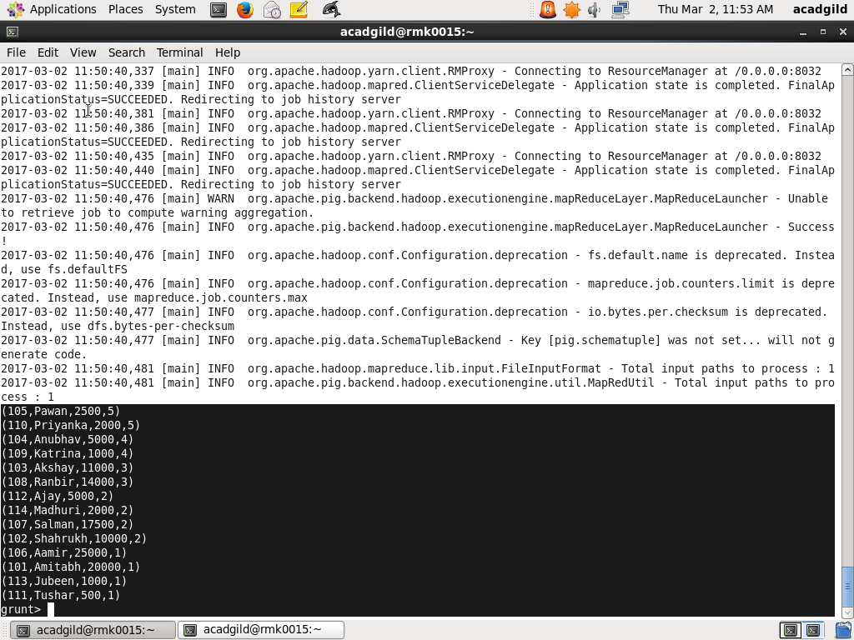

LIMIT: Top 5 employee details are retrived using the limit command .

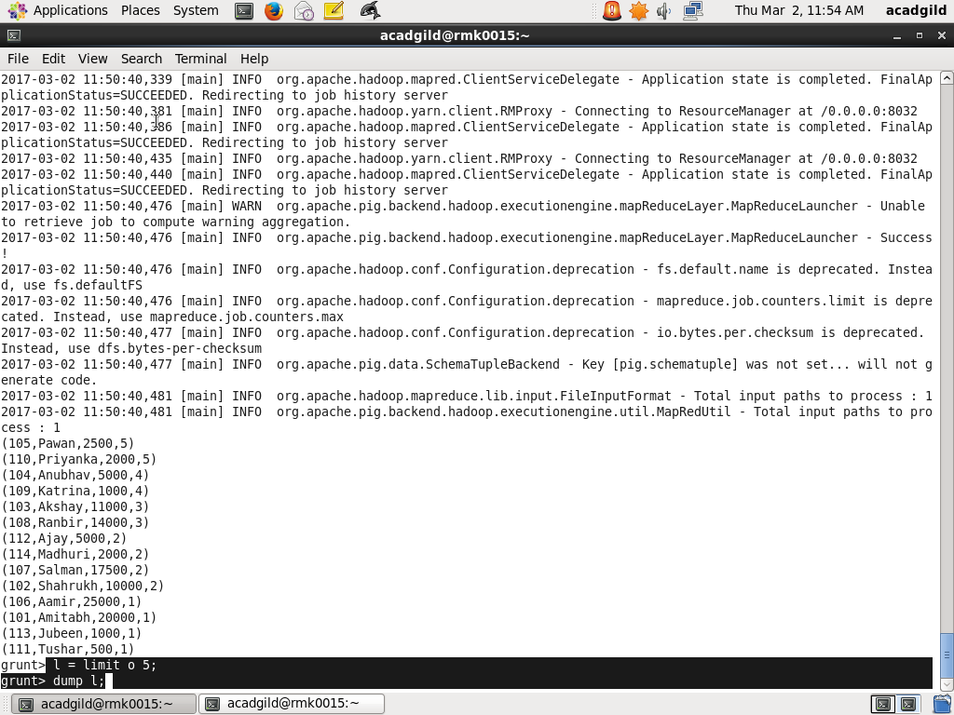

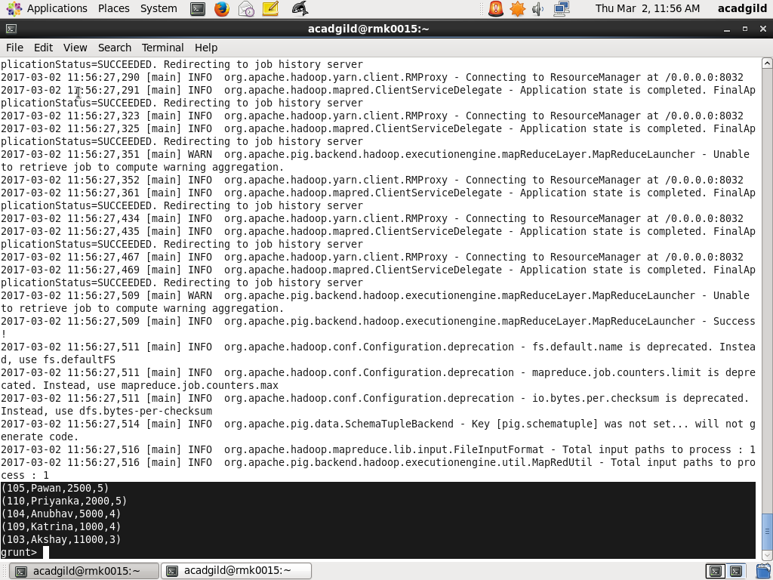



OUTPUT: The top five employee id’s and names with highest rating.

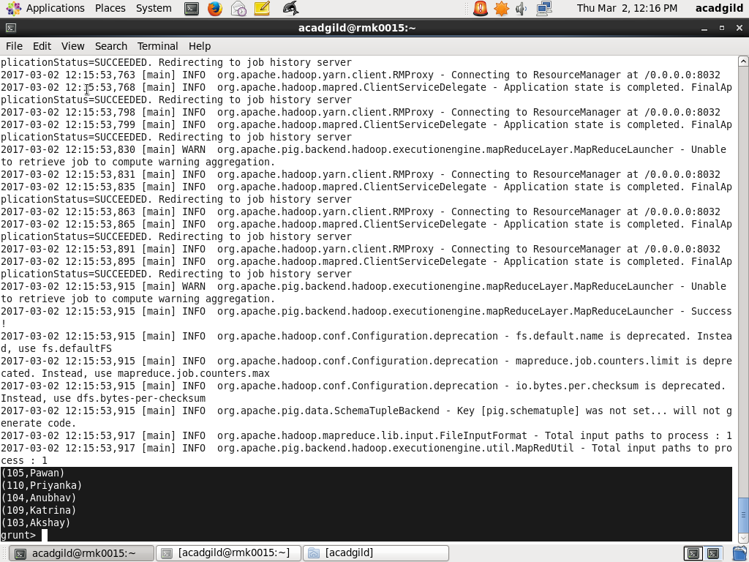

1. Top employees (employee id and employee name) with highest salary whose id is an odd number.

A)After loading the data into pig shell split the relation into 2 tables .one table conatins odd number of id’s and other table contains even number of id’s.

SPLIT: Split command is used to split the relation re1 into two relations .The relation re2 contains only the data with the odd number id’s.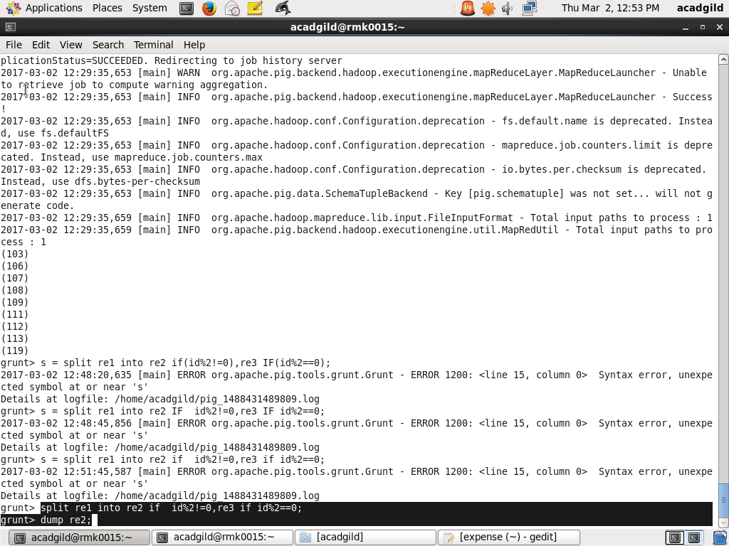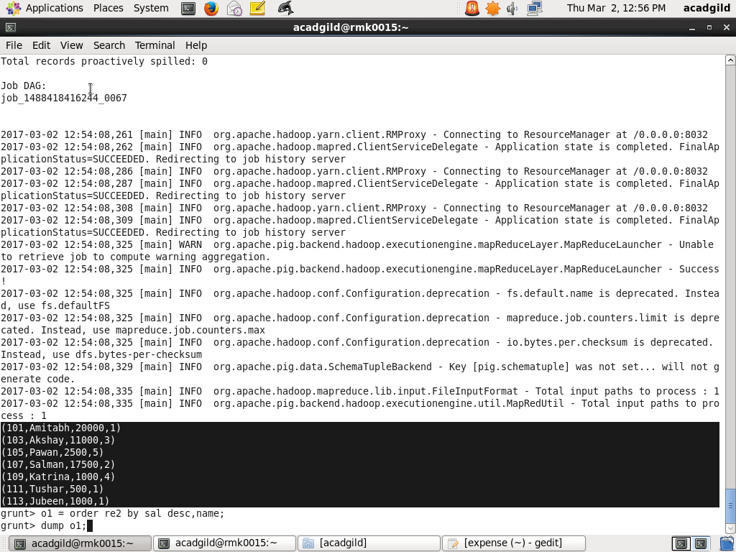ORDER: The order relation re2 by salary in descending order and name .

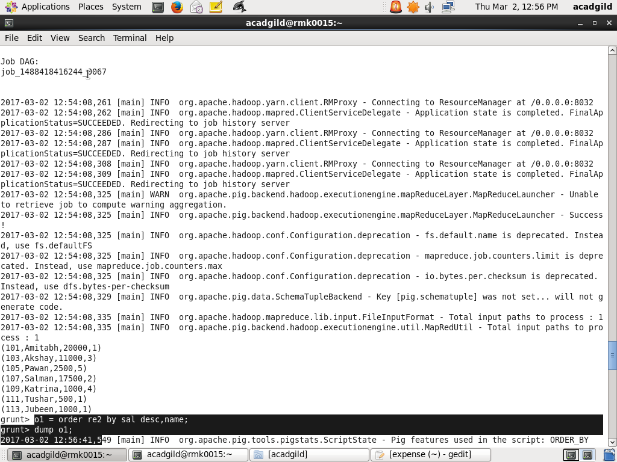

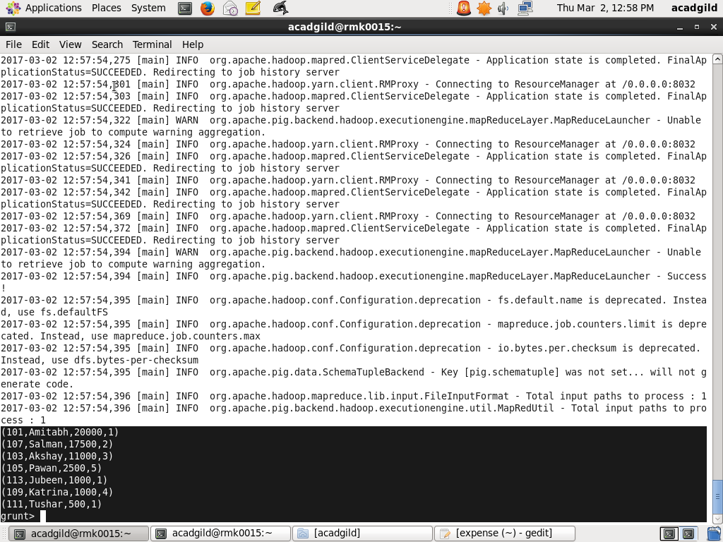

LIMIT: The top 3 employee details with the highest salary is retrieved.

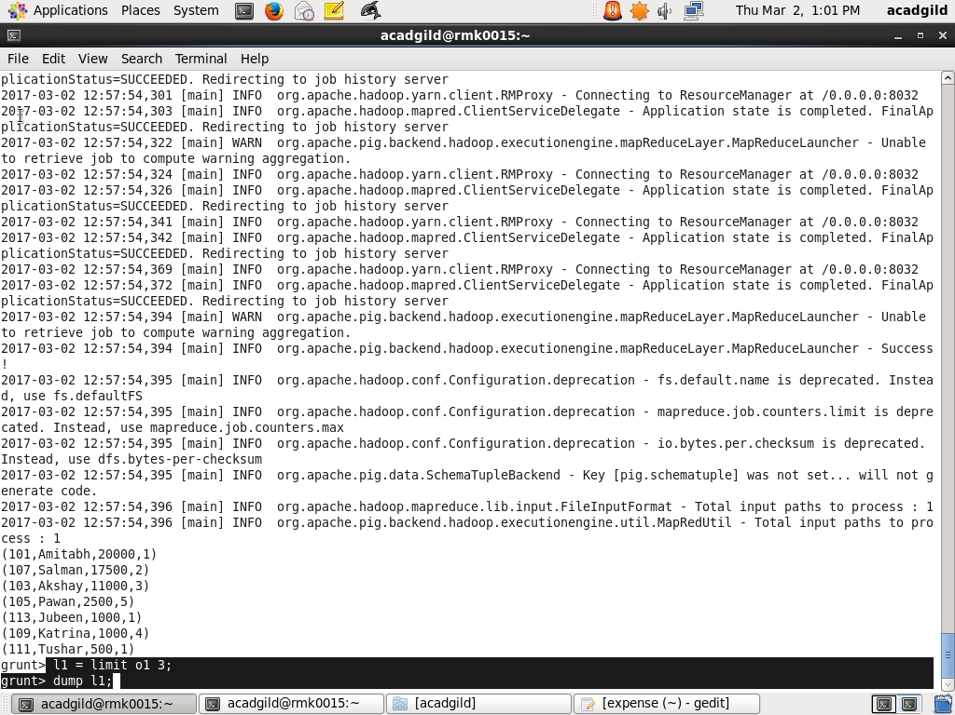

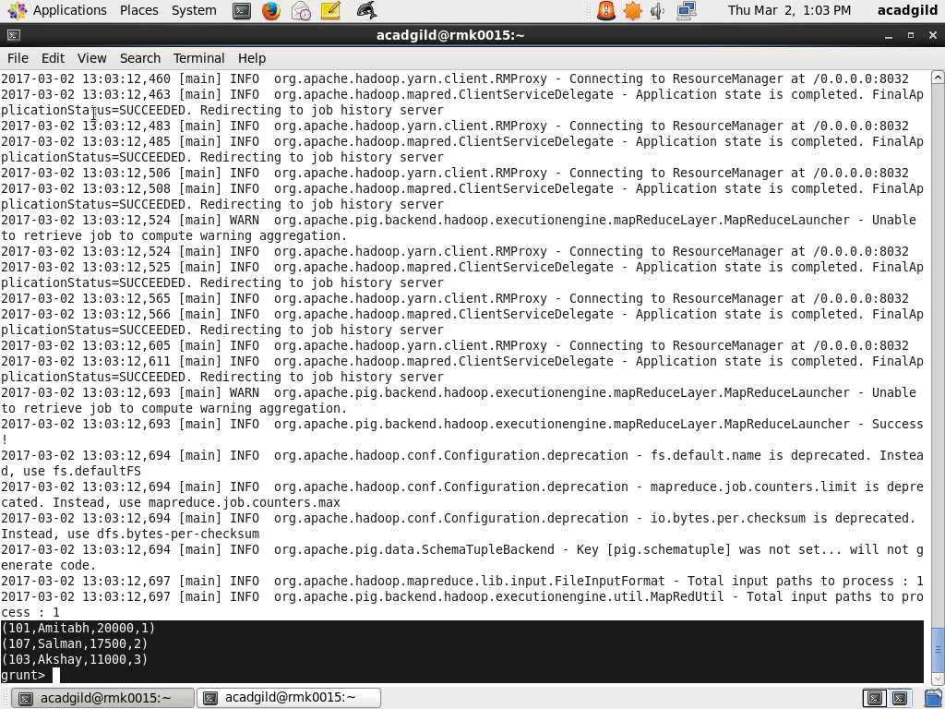

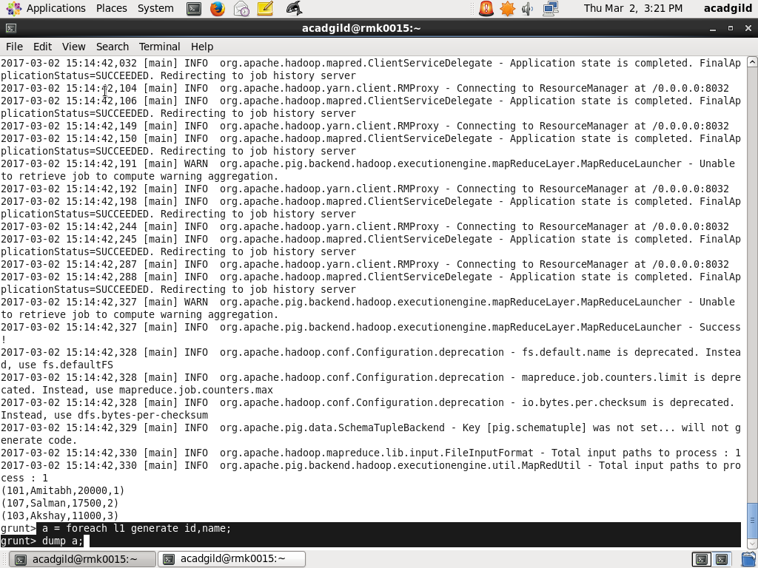

OUTPUT: The top 3 employees with the highest salary among odd id’s are retrieved.

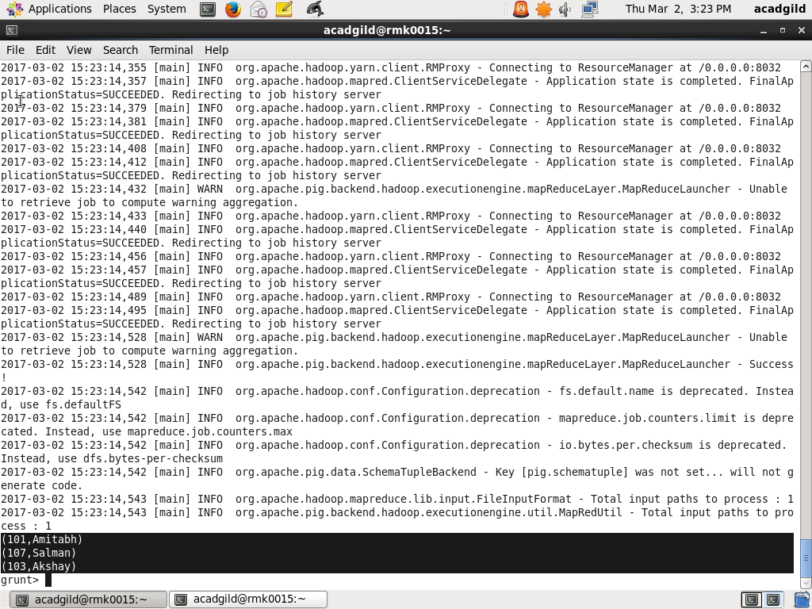

3) Employee (employee id and employee name) with maximum expense.

A) Create a relation re3 to load the expense data into the pig .

JOIN:After creating re3 join the two relations re1 and re3.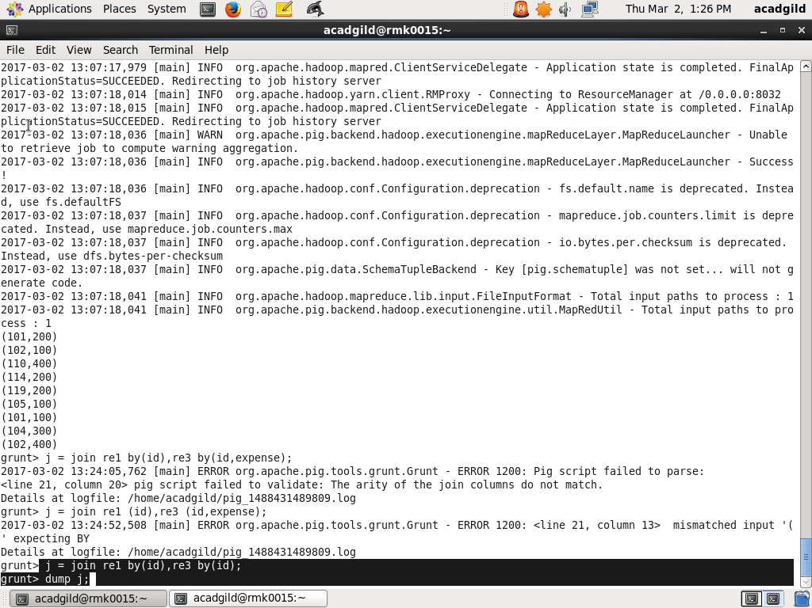

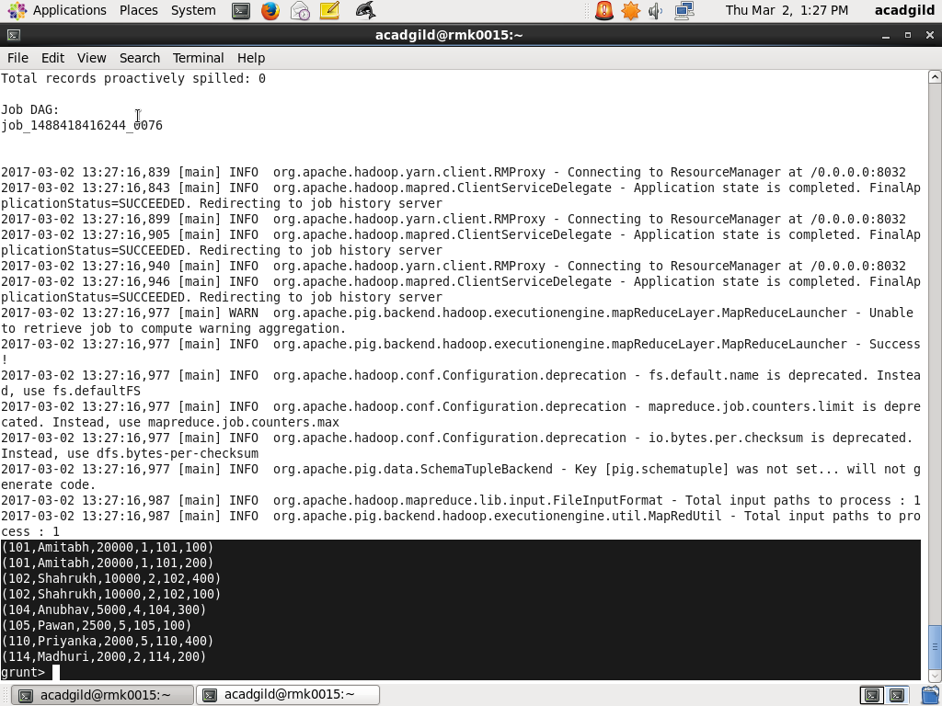

ORDER: Order the joined relations by the expense in the descending order and name.

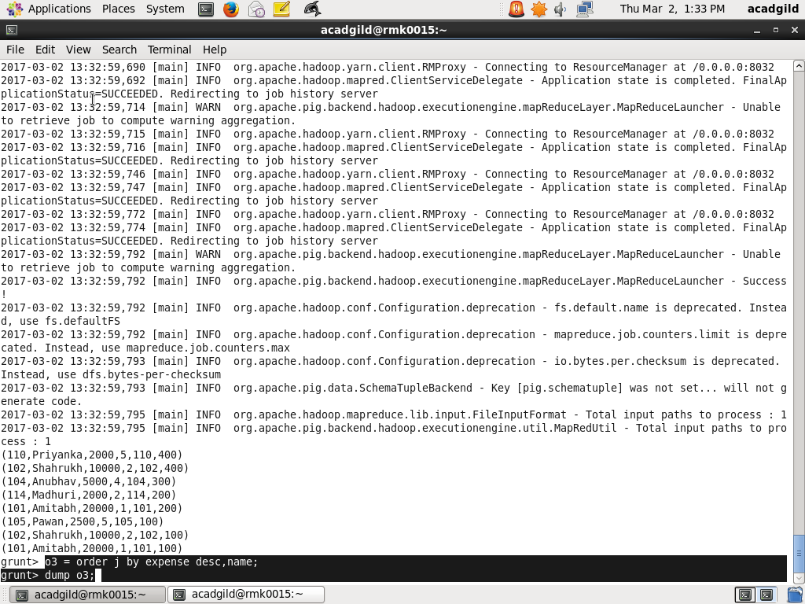

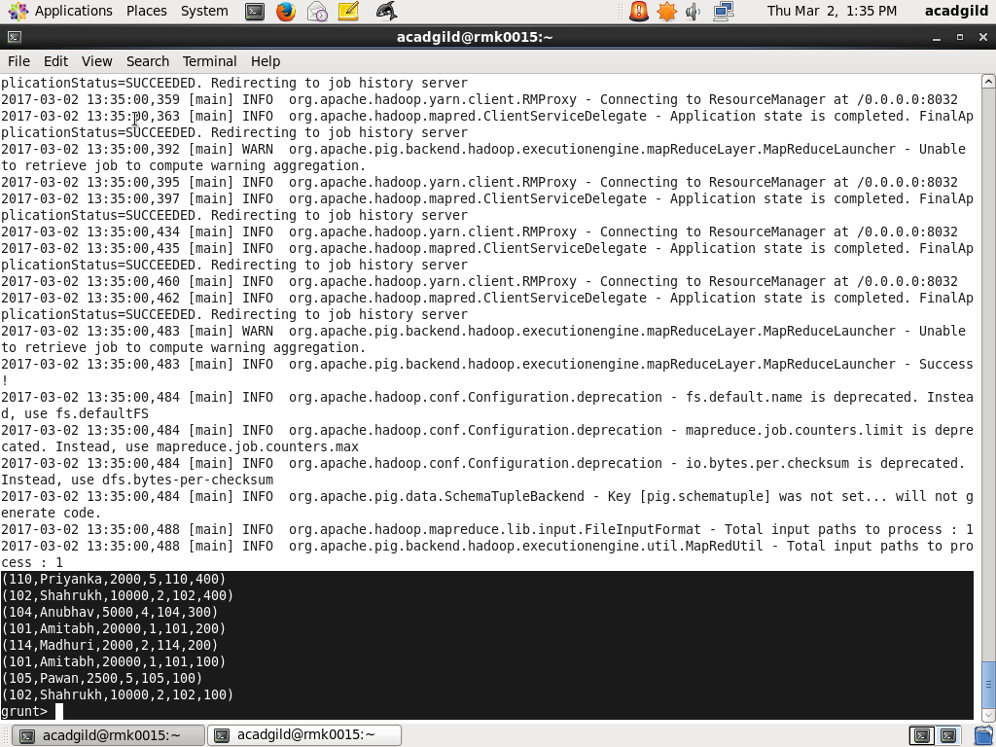

LIMIT: This command is used here to retrieve the employee with the highest expense.

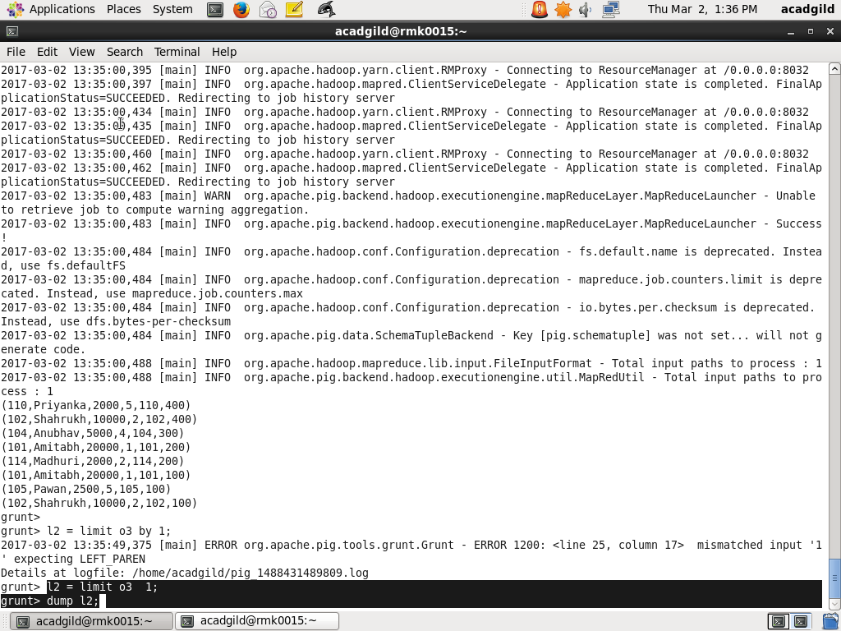

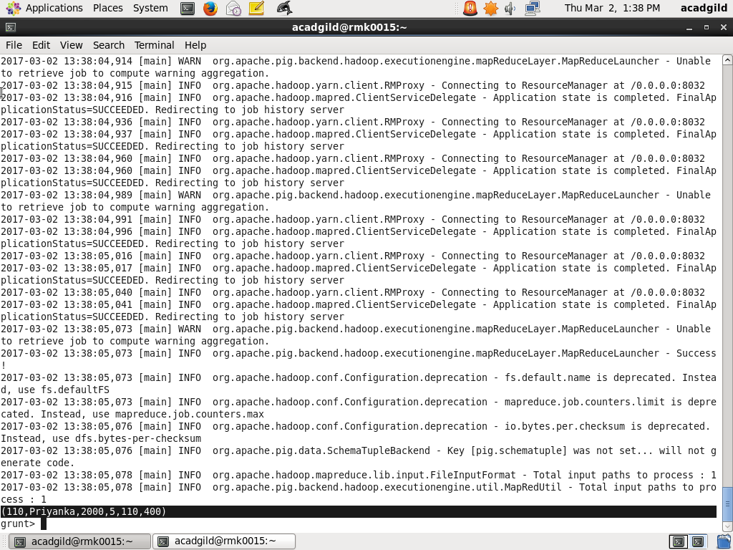

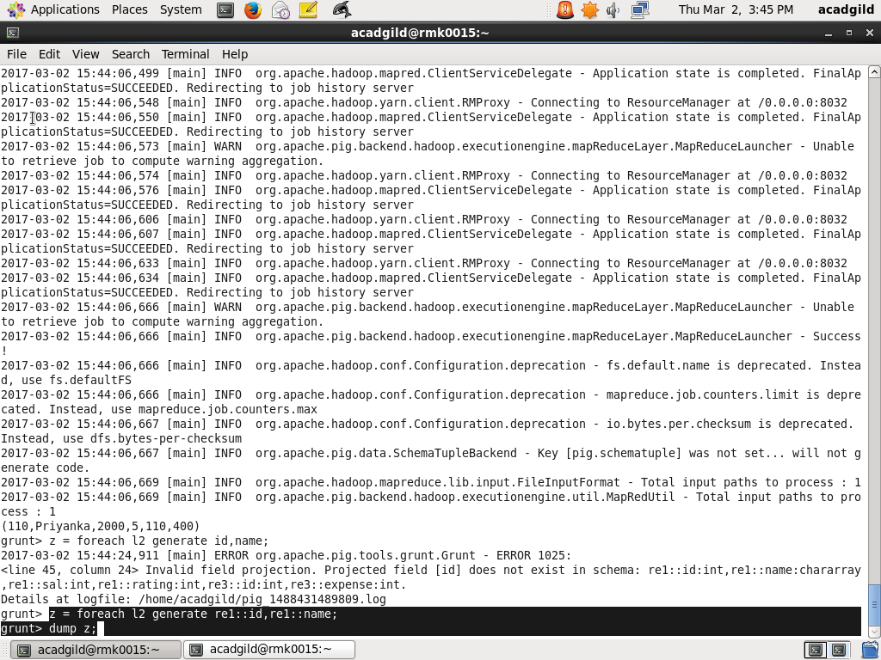

OUTPUT:

The employee name and id with the maximum expense is retrieved by generating the id and name for relation l2

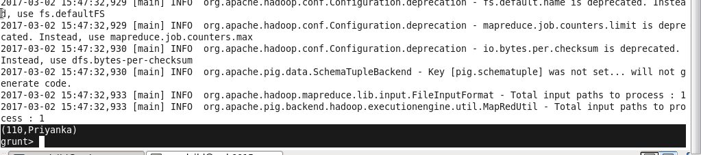

4) List of employees (employee id and employee name) having entries in employee_expenses file.

A) Join command is used to join employee and expense details.





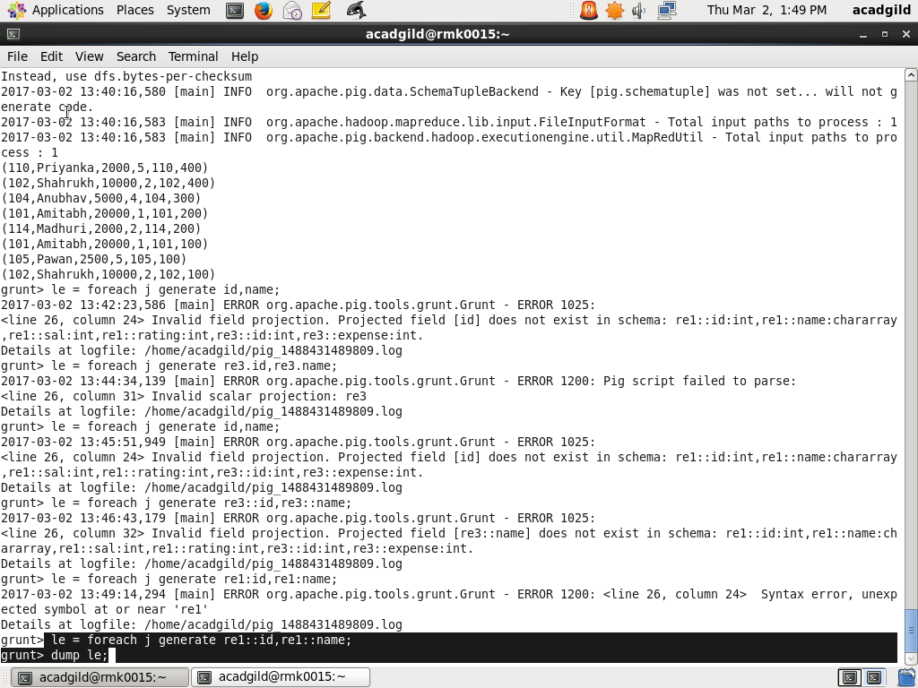

OUTPUT:

The employee id and employee name having entries in expenses.

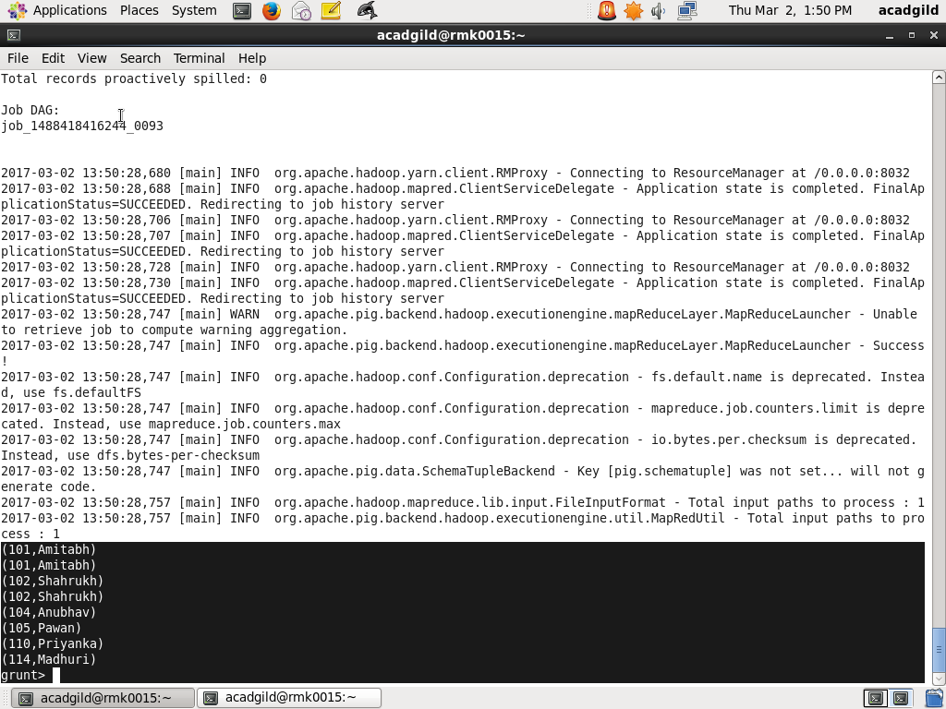

5) List of employees (employee id and employee name) having no entry inexpenses.

A) Join command is used to join two relations by id.

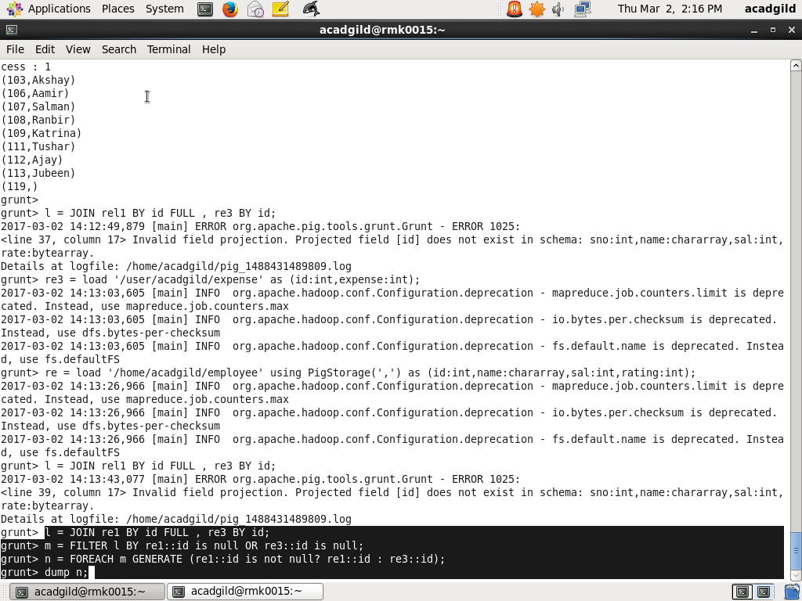

Output:

